**ECEN 214 - 302**

**Lab member: Alex Allahar**

**TA: Navid Naseh**

**Date lab performed: 8/4/22**

**Date report is due: 8/7/22**

1. **Procedure**

During this lab, I built a circuit that transfers power to a load. Task 1 used a sinusoidal voltage source with an amplitude of 4 volts and a frequency of 10 kHz with a 2200 Ohm resistor, a 0.12 H inductor, and a load resistor. Then I measured the magnitude of the load voltage across a 4, 6, 8, 10, 15, and 20 kiloohm load resistor. I would calculate the power dissipated for each load value.

For Task 2, I modified the circuit from Task 1 by putting a shunt capacitor in parallel with the load resistor. Using a constant load resistance value and varying the capacitance between 0.5, 0.8, 1, 1.5, 2, 3, and 4 nanofarads, I measured the new voltage across the load. For each capacitance, one would calculate the power dissipated in the load.

Finally, for Task 3, I used the values for load resistance and shunt capacitance that theoretically maximized power dissipation. With these values, I measured the voltage across the load resistor and the power dissipated across the load.

1. **Data and Results**

| Load resistance (kiloohms) | Load voltage, rms (V) | Power dissipated (W) |
| --- | --- | --- |
| 3.996 | 0.194 | 0.00000942 |
| 5.922 | 0.256 | 0.00001107 |
| 7.966 | 0.302 | 0.00001145 |
| 10.000 | 0.334 | 0.00001155 |
| 14.920 | 0.383 | 0.00000983 |
| 19.674 | 0.410 | 0.000000844 |

Table 1: Task 1 Data with varying load resistances

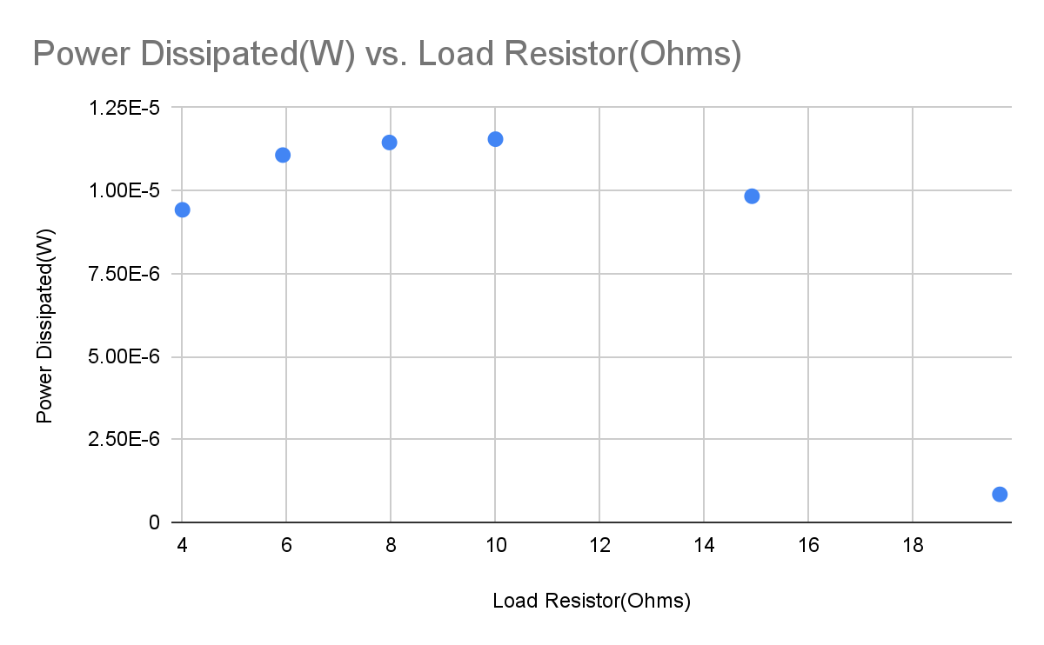

Figure 1: Plot of dissipated power vs. load resistance

When the circuit from Task 1 was solved during prelab, it was found that a resistance of 10622.9 ohms will maximize power dissipation in the resistor at 0.00384 watts to be dissipated in the load. This is similar with the actual behavior of the circuit shown in Figure 1, which shows a peak power for a load resistance around 10 kiloohms.

| Shunt capacitance (nanofarads) | Load voltage, rms (V) | Power dissipated (W) |
| --- | --- | --- |
| 0.5 | 0.378 | 0.0000125 |
| 0.8 | 0.354 | 0.0000143 |
| 1.0 | 0.430 | 0.0000185 |
| 1.66 | 0.428 | 0.0000184 |
| 2.0 | 0.461 | 0.0000213 |
| 3.33 | 0.120 | 0.0000014 |
| 3.99 | 0.379 | 0.0000144 |

Table 2: Task 2 Data with varying shunt capacitances (load resistor = 10 kiloohms)

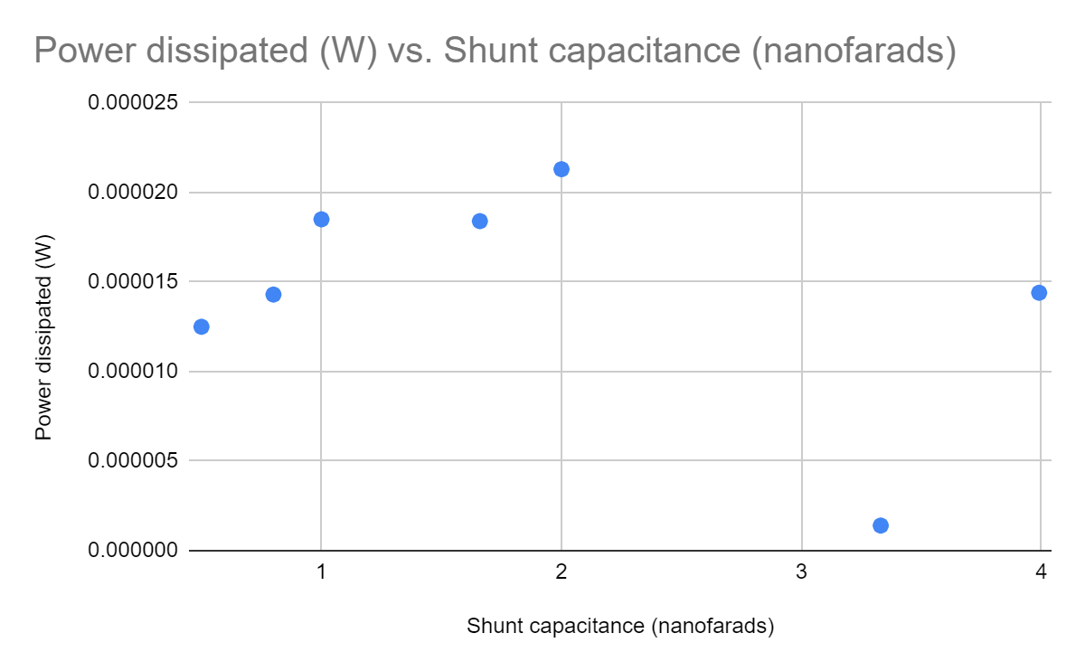

Figure 2: Plot of dissipated power v. shunt capacitance

When the circuit from task 2 was solved theoretically, it was found that a capacitance of 51.2 nanofarads with 10662.9 ohms load resistor would maximize the power and create a power of 0.000012 watts. However, the actual behavior of the circuit shown in Figure 2 shows a peak in power when the shunt capacitance is 2 nanofarads. This may be due to a different load resistance used during the lab than was used during prelab.

| Load resistance (kiloohms) | Shunt capacitance (nanofarads) | Load voltage, rms (V) | Power dissipated (W) |
| --- | --- | --- | --- |
| 28.043 | 2.0 | 0.736 | 0.00001932 |

Table 3: Task 3 data for a combination of resistance and capacitance

During prelab, it was determined that, if one can control both the shunt capacitance and load resistance values, then the maximum power will occur for a load resistance of 106629 ohms and a shunt capacitance of 51.2 nanofarads, which together will cause a power of 0.000012 watts. The difference between these numbers and the actual numbers shown in Table 3 is most likely due to the different voltages used for the voltage sources..

1. **Discussion**

The differences between measured and theoretical values were significant for the Task 2 and 3. This could be due to bad calculation of the shunt capacitance and thus affecting maximum power in Task 3.

Dissipated power significantly improves as we have more control over the impedance of the load. When there is just a load resistance that I could change, I am able to create a maximum power around 0.000012 watts with a 10000 ohm resistor. Once I added a shunt capacitor to a circuit, I was able to get a maximum power of 0.0000213 watts by using a 2.0 nanofarad capacitor for the shunt capacitance. Once I has control over both the resistance and reactance of the load, I could create a peak power of 0.00001932 watts. This lower value is due to a change in the load resistor for the the final Task. However, still the trend shows the more control over the impedance the more maximum power we can get out of the circuit. The total difference between Task 1 and Task 3 is 0.00000732 watts.

1. Conclusion

During this lab, I experimented with delivering power to a load. Through the process, I learned how to maximize power to a load when I can control both the resistance and reactance of the load. The lab also demonstrated how significantly I can improve the power dissipation in the load by being able to change component values.